The analog of the ‘hello world’ example in concurrent programming is probably the in-famous dining philosophers problem. Made famous in this form by C.A.R. Hoare (also of QuickSort fame), the set up for this puzzle is quite straightforward: there are four philosophers sitting at a table wanting to eat. The catch being that there are only four forks on the table and a philosopher needs to use two forks to eat something from the table.
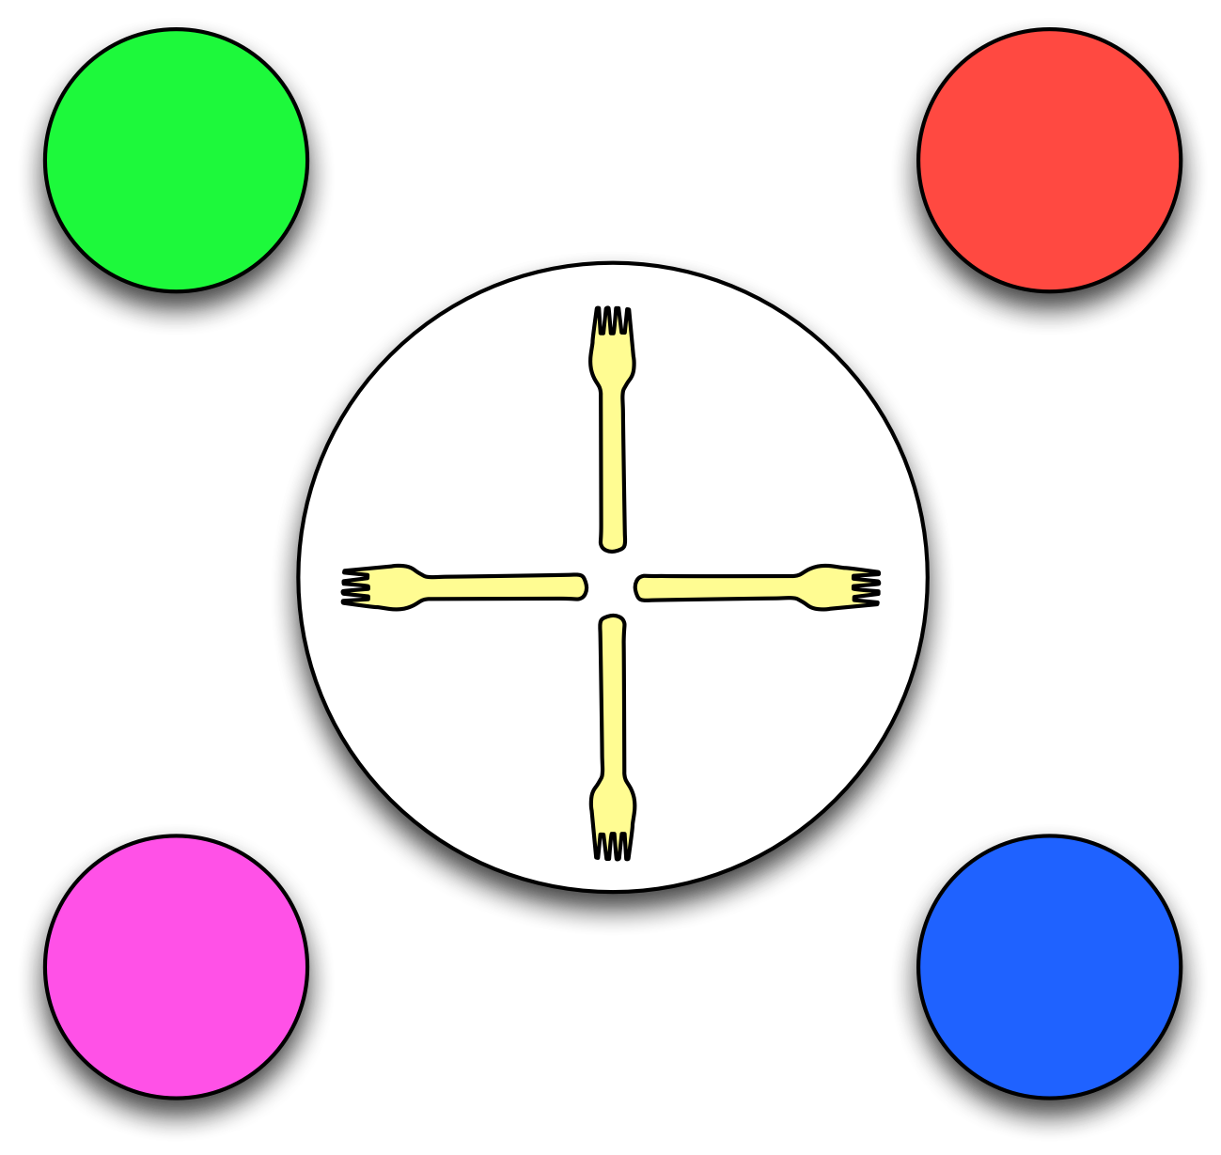
Four Dining Philosophers
Of course, it is only a little eccentric that the philosophers eat with two forks rather than a knife and fork!
Being philosophers, they don’t eat constantly: they spend some time talking too; which means that it is possible for them to share the forks. Each philosopher has access to the two forks nearest him; each fork is shared by two philosophers; but a given fork can not be in use by more than one philosopher simultaneously.
This problem is one of resource contention and the underlying issue is to avoid the different kinds of contention issues — such as deadlock (where everyone is stuck and no progress can be made), livelock (where no effective progress is made) and starvation where one or more of the philosophers receives an unfair allocation of the forks — preventing others from using the forks.
There are two well-known solutions to the dining philosophers problem; one is due to Hoare and the other is due to Mani Chandy. We will show how to realize Hoare’s solution as it introduces some additional features of our concurrency platform.
In essence, the Hoare solution depends on a combination of semaphores to manage the status of the various forks and an additional arbitrator to ensure deadlock-free execution.

